Guidance and Best Practices to address the effects of Global Pandemics (COVID-19) on Local Agency Projects

This Local Agency Bulletin provides guidance and best practices to address the effects of COVID-19 on locally-administered projects in Colorado. Please be aware that a Local Agency may have issued more restrictive guidance specific to its organization that supersedes this information.

Safety Concerns:

Section 8.2, Project Safety, of the Local Agency Manual states:

Before construction commences on the project, the Contractor must submit a Project Safety Management Plan compliant with Section 107.06 of the CDOT Construction Manual. The Contractor is expected to comply with the Plan at all times. Safety is of the highest priority on CDOT projects, which includes Local Agency projects.

Due to concerns regarding health and safety related to the current Global Pandemic (COVID-19) on active construction projects, Local Agencies should require Contractors to update their Project Safety Management Plan in accordance with Standard Specification 107.06, Safety, Health, and Sanitation Provisions. This specification states that the Contractor shall, “…provide updates to the (Project Safety Management) Plan as necessary, and as work conditions or personnel changes.”

CDOT has drafted the following Form 105, Speed Memo, for use on CDOT projects and encourages Local Agencies to adopt and revise this information as necessary for use on their Local Agency projects.

Following is a CDOT Chief Engineer Memo listing issues a Project Safety Management Plan should address:

Local Agencies are requested to embrace and implement the following Multi-Industry Construction Guidance recently issued by Colorado Department of Public Health and Environment on all projects.

Local Agencies and their Contractors are also notified of the April 3, 2020 recommendation from Governor Polis to all Coloradans to wear a non-medical face covering or mask when leaving their homes to do essential activities. This includes working on a Local Agency project. Excerpt follows:

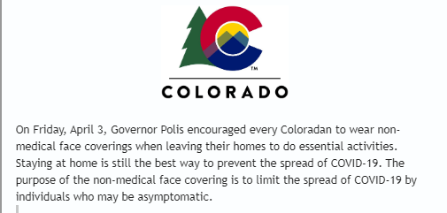

Technician Certifications:

During the COVID-19 pandemic, CDOT is allowing temporary extensions to Technician Certifications that may lapse due to cancellations in the available training/recertification courses. Following is a CDOT Chief Engineer Memo addressing this issue on CDOT projects. Local Agencies are encouraged to adopt similar measures during this time.

This Local Agency Bulletin is effective immediately and applies to all Local Agency projects, regardless of funding.

Please print out this information and update your copy of the Manual. For additional questions, contact your CDOT Region Local Agency Coordinator or CDOT Project Manager.

